

Practices for Secure Software Report

Table of Contents
Document Revision History 3
Client 3
Instructions 3
Developer 4
1. Algorithm Cipher 4
2. Certificate Generation 4
3. Deploy Cipher 4
4. Secure Communications 4
5. Secondary Testing 4
6. Functional Testing 4
7. Summary 4
8. Industry Standard Best Practices 4

Document Revision History

Version | Date | Author | Comments
1.0 | June 20th, 2026 | Kaylee Thornhill

Client



Instructions

Submit this completed practices for secure software report. Replace the bracketed text with the relevant information. You must document your process for writing secure communications and refactoring code that complies with software security testing protocols.

- Respond to the steps outlined below and include your findings.
- Respond using your own words. You may also choose to include images or supporting materials. If you include them, make certain to insert them in all the relevant locations in the document.
- Refer to the Project Two Guidelines and Rubric for more detailed instructions about each section of the template.

Developer
Kaylee Thornhill

Algorithm Cipher

For this project I used the SHA-256 for the checksum verification step and HTTPS/TLS for secure communication. SHA-256 is not encryption in the same way that a cipher like AES is, because it doesn’t hide data or decrypt it later. It creates a fixed hash value instead that can be used to verify whether data has changed. This makes it a good fit for Artemis because the company needs a file verification step to protect the integrity of transferred data.
For secure communication, I also configured the application to use HTTPS with a self-signed certificate. HTTPS uses both asymmetric and symmetric encryption. The asymmetric keys help establish a secure connection, while the symmetric key is used to encrypt the data being transferred. Older algorithms like MD5 and SHA-1 are no longer considered secure, so using SHA-256 and HTTPS provides stronger protection for Artemis Financial’s client data.

Certificate Generation
Insert a screenshot below of the CER file.

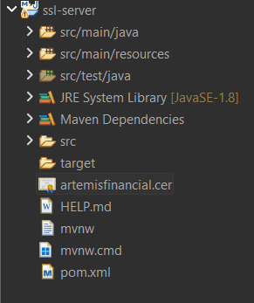

Deploy Cipher
Insert a screenshot below of the checksum verification.

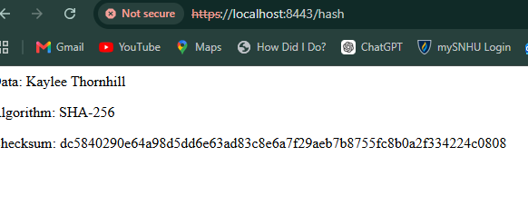

Secure Communications
Insert a screenshot below of the web browser that shows a secure webpage.



Secondary Testing
Insert screenshots below of the refactored code executed without errors and the dependency-check report.

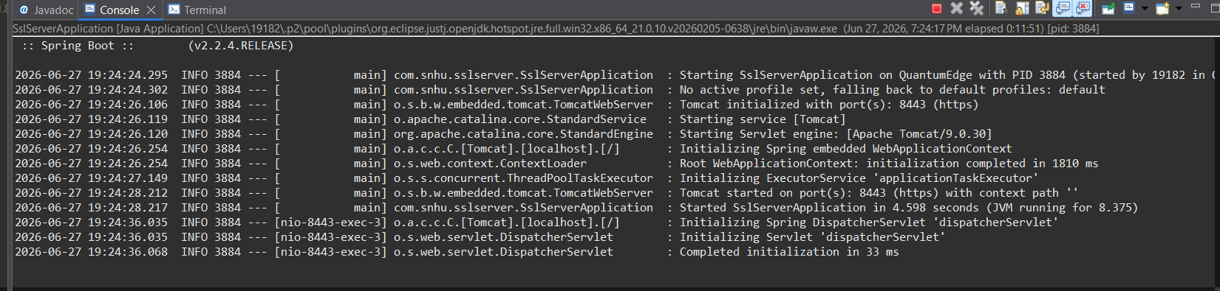
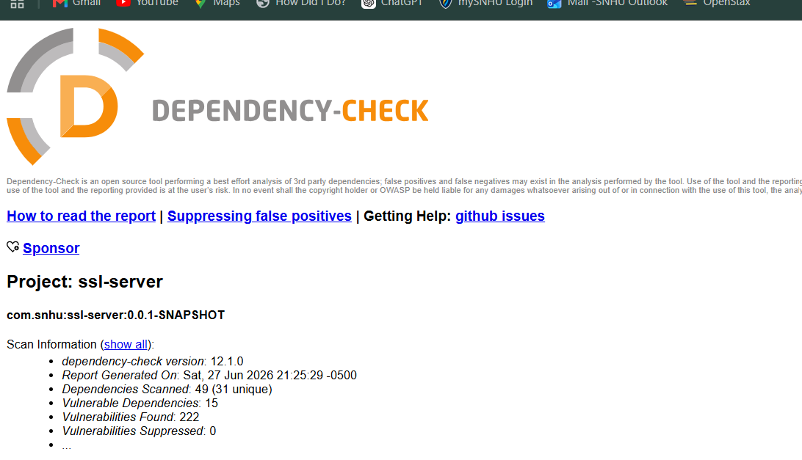

Functional Testing
Insert a screenshot below of the refactored code executed without errors.


After I finished refactoring the application, I manually reviewed the code to check for syntax, logic, and any obvious security issues. I tested the application to make sure the SHA-256 checksum was generated correctly using my unique data string and verified that the /hash endpoint responded as expected. I also confirmed that the application ran over HTTPS using the self-signed certificate. Overall, the application compiled and ran without errors, and I didn't find any syntax or logical issues during my testing.

Summary

I refactored the application by adding a SHA-256 checksum and configuring it to use HTTPS with a self-signed certificate. These changes addressed two main areas of security from the vulnerability assessment process: protecting the integrity of the data being transferred and securing communication between the client and the server. To add layers of security, I first generated and configured the certificate so the application could run over HTTPS. Then I added the SHA-256 checksum to verify that the data had not been changed during transmission. After making those changes, I tested the application to make sure it compiled successfully, the /hash endpoint worked correctly, and the secure connection was established.

Industry Standard Best Practices

I followed industry standard secure coding practices by using SHA-256 instead of older hashing algorithms like MD5 or SHA-1 and by configuring the application to use HTTPS for secure communication. I also used Java's built-in security libraries instead of creating my own hashing method, which helped maintain the application's existing security while adding new security features.
Using secure coding best practices is important because Artemis Financial works with sensitive financial information. Strong security helps protect customer data, reduces security risks, and makes the application easier to maintain as security standards continue to evolve.

